Appendix 1. Calibration Data

A flow test was conducted for each tipping bucket rain gauge (TBRG) to derive calibration coefficients to normalize differences among TBRG. A modified, manual version of the Humphrey et al. (1996) dynamic calibration system (Fernandez et al. 2018) was implemented. A standard reservoir of 500 ml of water is automatically pumped into the TBRG (Figure 1). The flow is regulated by the voltage applied to power the peristaltic pump. Higher voltage results in high rotation rate and flow. We simulate typical low flow fog drip events by setting the voltage at 6.1 V. Dense fog drip is simulated at 8 – 10 V.

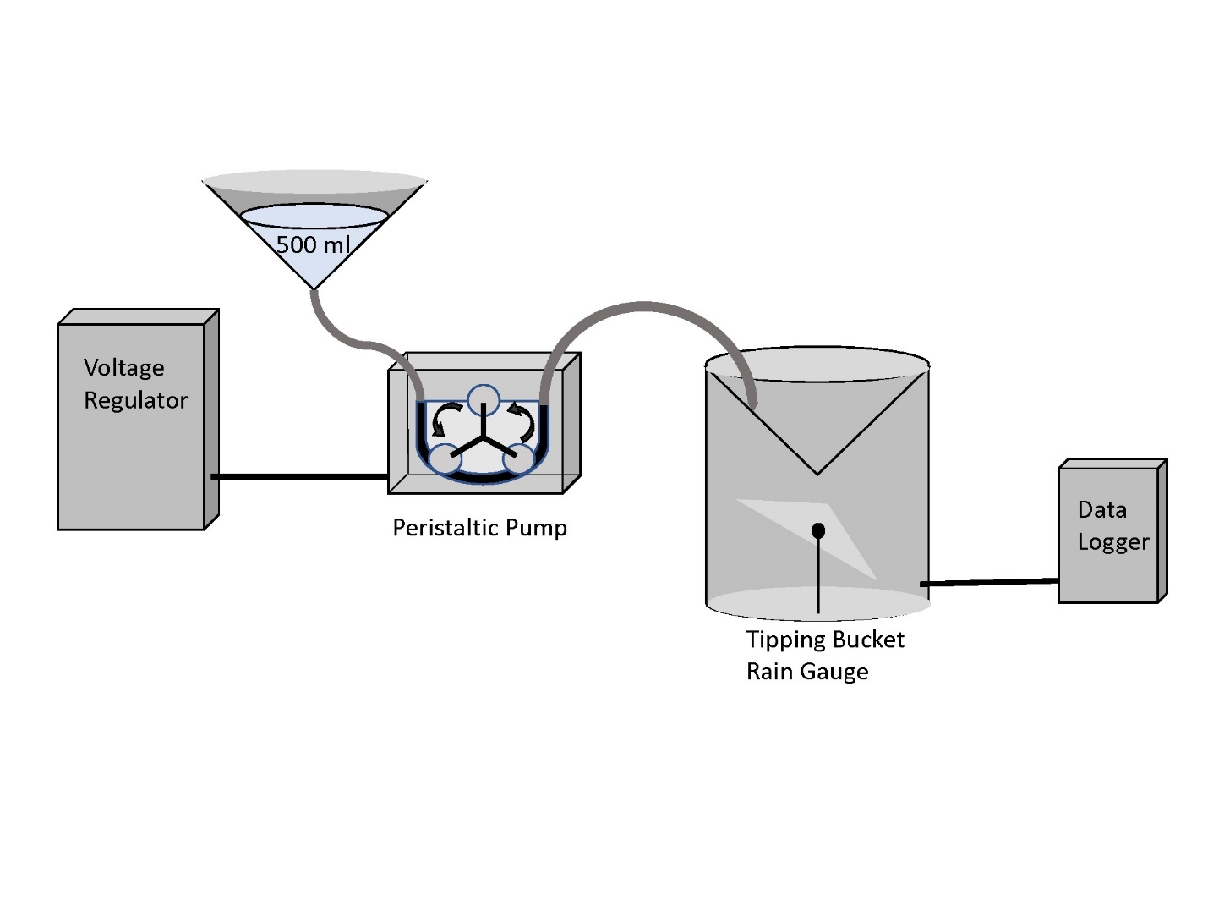

Table 1. Calibration data for six tipping bucket rain gauges (TBRG) deployed at Skyline Field Office site.



Table 2. Calibration data for six tipping bucket rain gauges (TBRG) deployed at North Purisima site



Table 3. Calibration data for TBRG at different voltage to simulate different flow intensities. Data were logged at one minute intervals. Intervals with no tips (P6 at 4.0 V) were compressed into one record.



References

Humphrey, M. D., Istok, J. D., Lee, J. Y., Hevesi, J. A., & Flint, A. L. (1997). A new method for automated dynamic calibration of tipping-bucket rain gauges. *Journal of Atmospheric and Oceanic Technology*, *14*(6), 1513-1519.

Fernandez, D.M., Torregrosa, A., Weiss-Penzias, P.S., Zhang, B.J., Sorensen, D., Cohen, R.E., McKinley, G.H., Kleingartner, J., Oliphant, A. and Bowman, M., 2018. Fog Water Collection Effectiveness: Mesh Intercomparisons. *Aerosol and Air Quality Research*, *18*, pp.270-283.